Relationship Entity Diagram:
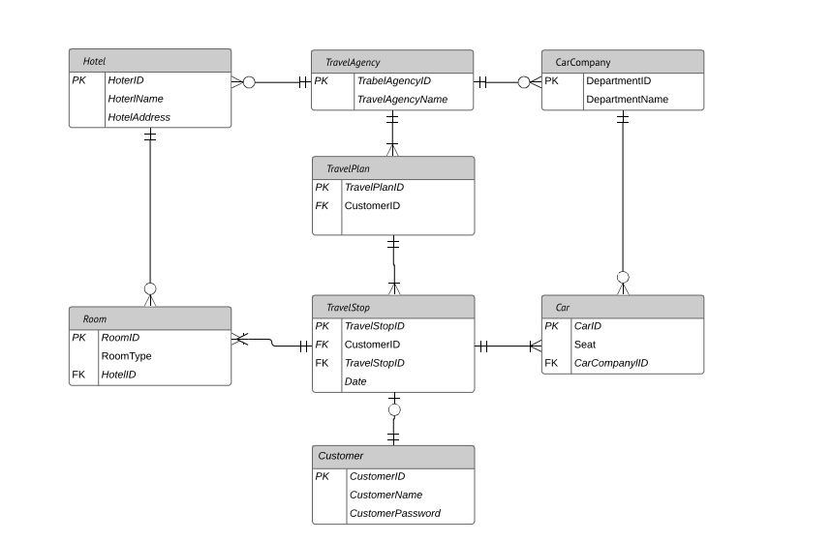
Class Diagram:
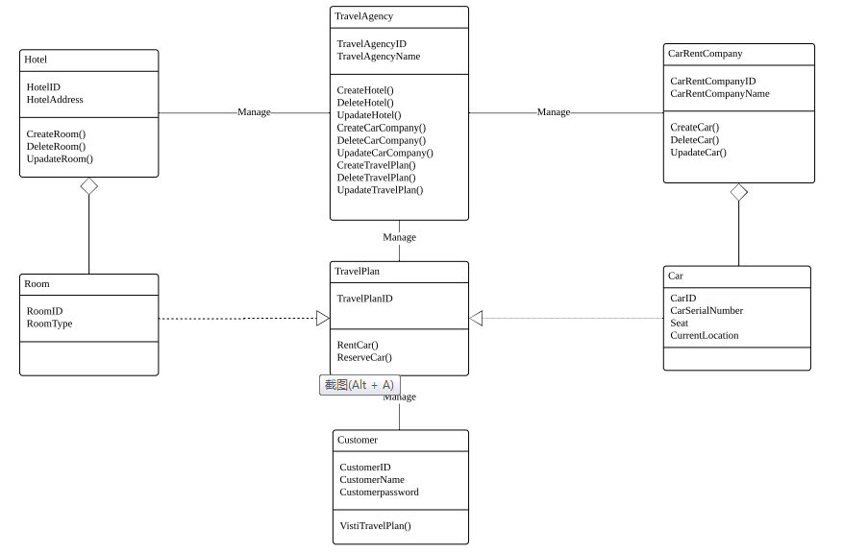
Object Diagram:
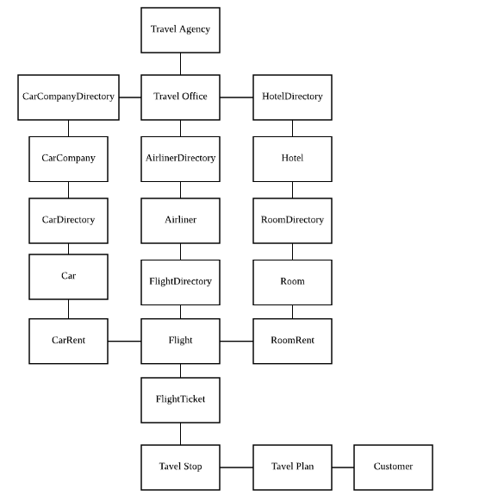

Travel Agency as parent company have multi-retailer eactly are Travel Office. Also each Travel Office manage a series of Car companies, Hotel companies and Airliners which can be defined as directory. Car company could manage a collection of cars. Hotel company could manage a collect of hotels. Airliner could manage a collection of airplanes and flights.
Customer could view information about all cars , hotels and flights though sending requests to agency offices. As soon as customers decided waht to choose, Travel office could make travel plans for customers. And a travel plan could be made up of one to many travel stops. Each travel stop contains the information of car rent , hotel rent and flight ticket where one or two of them could be empty. If end date of travel stops and destination of travel stops of the same customer equals start date and start address accordingly , travel office could link these stops together to form a travel plan. Certainly one travel could contain only one travel stop.

